1. **Difference between map filter and foreach**

* **Map**
  + Map is most use in array method
  + Its a make new array based on existing array
  + Fst its iterate one by one and add 10 then added a new array

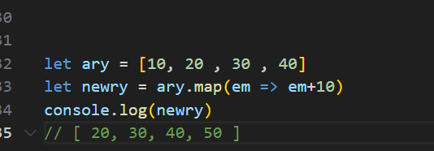

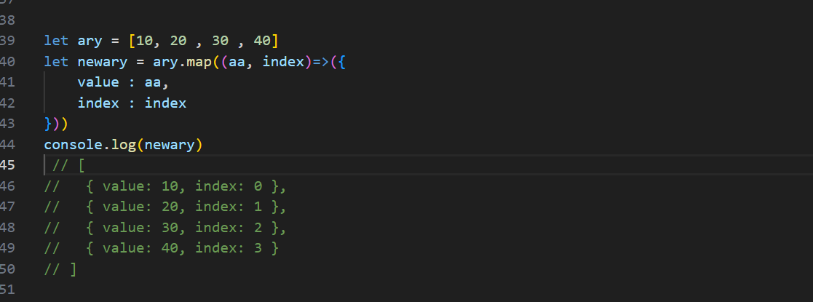

* **Filter**
  + Filter is a javascript inbuilt method
  + Whenever the condition or statement is true these function return the true value and make a array
  + If statement or condition value is false its skip the value and return a array

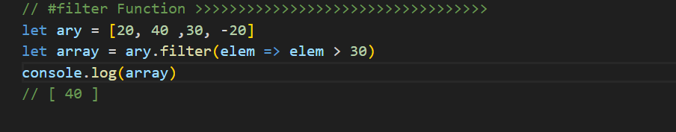

* **Reduce:**
  + A reduce function is a higher function in javascript
  + Its allows to array an reduce all element in one value
  + It take 2 arguments one is callback function and another is initialvalue
  + The callback function iterate over the array
  + The initial value what is the current value of iterate array
* **Foreach** 
  + It's a one method of an array
  + It's used to iterate over the array elements

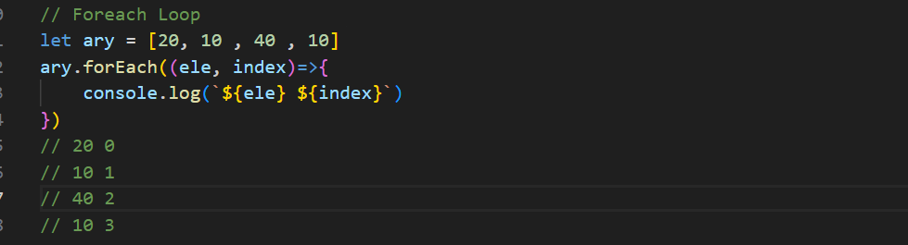

1. **What is Hoisting in javascript** **?**
   * 1. Hoisting is when we use function or variable before declaration its called hoisting

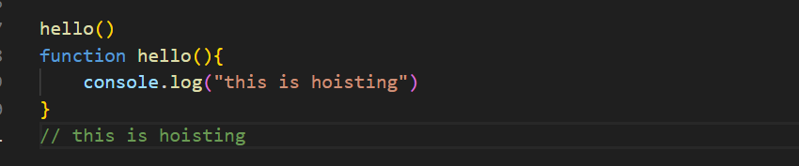

1. What is Closure In Javascript ?
   1. Clouser is a combination of function and the lexical environment
   2. They enable concepts like private variables and data encapsulation in JavaScript.
   3. Lexical Environment : it's a internal data structure used to store and handle the variable and function during runtime
   4. Below mention this example the lexical environment is a when abhi() function call the variable name is going not value so it can update the value

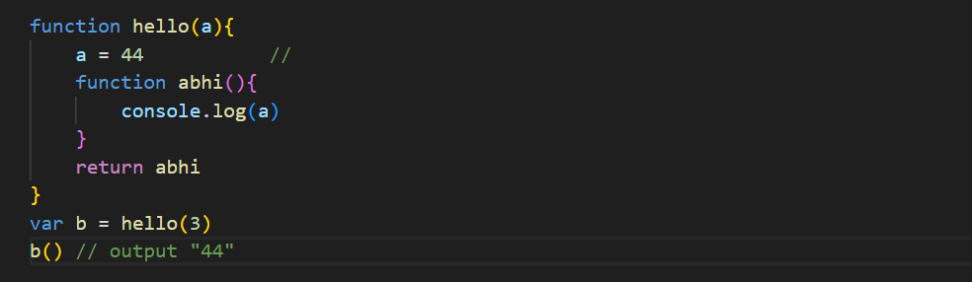

1. **Event Bubbling and Capturing in javascript ?**

* **Bubbling: -**
* Bubbling means when we add any event any element or button so if the parent elements have any event so whenever we click the child event first it action child element then going to parent element like (child to parents)
* Below mention this image bubbling
* 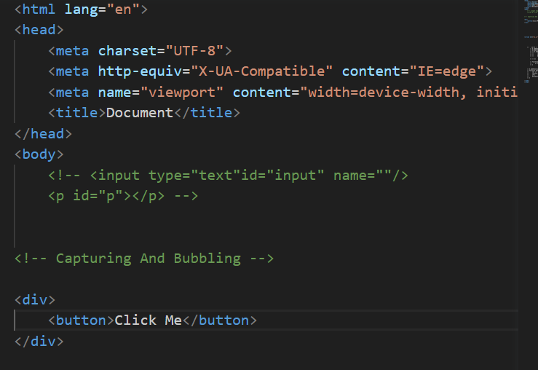
* 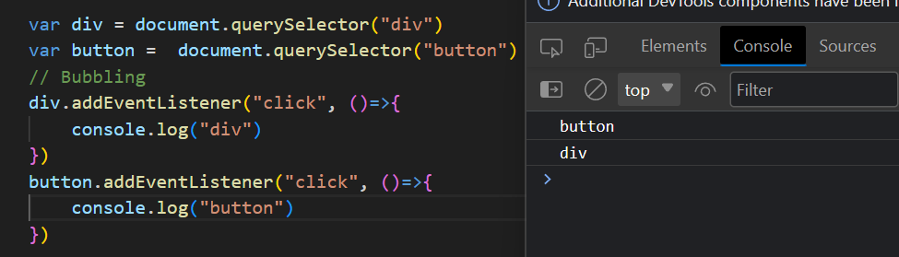
* **Capturing :-**
  + It means when we add any event any child elements if the parents elements have any event so it can first action parents then action child (its like parents to child)
  + Below mention this image left side Capturing



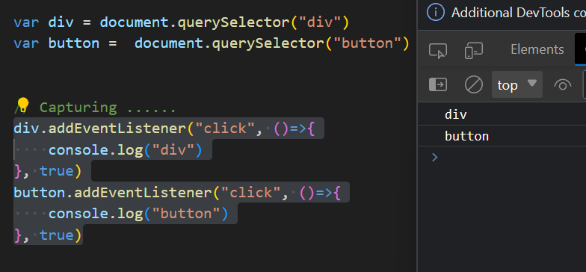

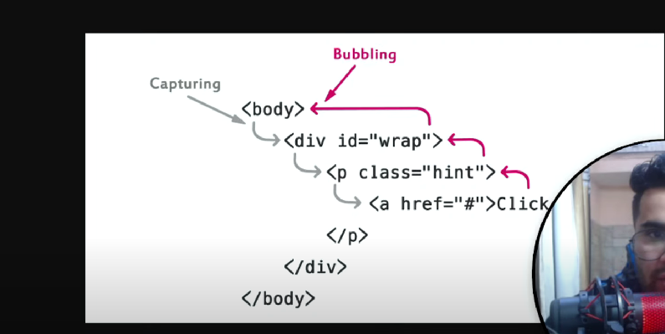

**5. What is StopPropagation and Immediate Propagation and Prevent Default**

* The bubbling method mean the event action childs to parents if we want to add event only child elements so that time we use **StopPropagation** whenever the event is work its only action child elements



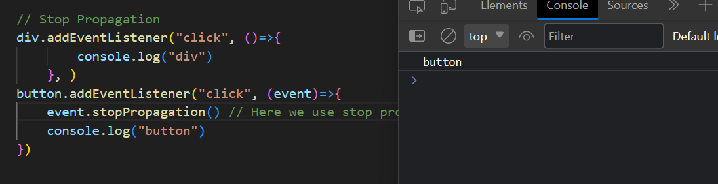

**StopImmediate Propagation:**

* When we add two functionality using in one element events if we want to using only one functionality that time we use immediate propagation its work one functionality then stop

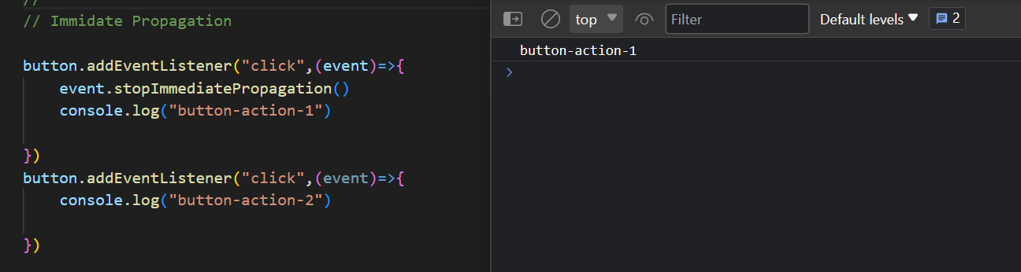

* **PreventDefault(** rokna or stop this **) :-**
  + It means when i click a anchor tag the page is rendering to another page if we want to stop this rendering that time we use PreventDefault

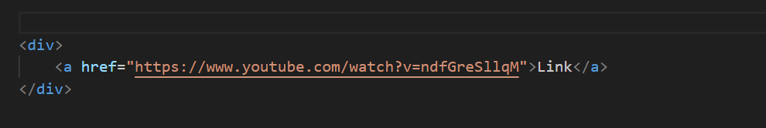

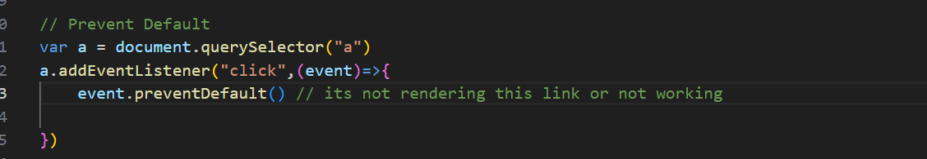

* **What Is Debouncing and Throttling**